BUSINESS IDEA AND BUSINESS OPPORTUNITY

An entrepreneur is an opportunity seeker or rather an entrepreneur is a person with clear and compelling vision for his or her businesses. His/her first task is to identify and select a good business opportunity.

Definition of Entrepreneurial Opportunity.
An entrepreneurial opportunity is defined as an attractive project idea, which an entrepreneur accepts as a basis for an investment decision on the basis of what is known about the possible success for the project.

Recognition of entrepreneurial opportunities is at the core of entrepreneurship and enterprise development; entrepreneurs will identify an opportunity following which they are able to create a product, a process or something of value for someone (Hisrich and Peters 2002: 10). Kuratko and Hodgetts (1998: 32) agree that creativity and vision are fundamental traits required by entrepreneurs. The entrepreneurial process begins with an entrepreneur’s ability to identify or recognize an opportunity. The entrepreneur will creatively devise ways to bring this opportunity to fruition. (Timmons 1999: 38, 39) The importance of creativity and innovation cannot be over emphasized.

The process of recognizing entrepreneurial opportunities starts with the generation of business ideas, which are then subjected to rigorous screening to obtain business/entrepreneurial opportunities.

Generation and validation of business ideas
A good business idea is essential, or even a prerequisite, for a successful business venture. However, good business ideas do not usually just occur to an entrepreneur. Rather, they are the result of hard work and effort on the part of the entrepreneur in generating, identifying and evaluating opportunities.

To be successful in business, an entrepreneur should have several business ideas out of which one selects the best option based on economical viability and technical feasibility
(KAB Facilitator Handbook 2005, ILO)

Entrepreneurs need to be creative in many different areas of the entrepreneurial process if they are to achieve their goals (Glancey and McQuaid 2000:9). Hisrich and Peters (2002:10) define entrepreneurship as: “the process of creating something new with value by devoting the necessary time and effort, assuming the accompanying financial, psychic and social risks and receiving the resulting rewards of monetary and personal satisfaction and independence.” This is the motivation that drives many to found enterprises and pursue them even to become business empires.

FACTORS THAT ASSIST IN IDENTIFYING BUSINESS IDEAS

Environment
These are the basic features of an area and its resources e.g. The climate, geographical location, population. By looking at the population, its composition, occupational patterns and social economic background one can come up with a business idea.

A systematic relationship exists between a country’s level of economic development and its level and type of entrepreneurial activity. Countries with similar per capita GDP tend to exhibit similar levels of entrepreneurial activity, while significant differences exist across countries with different per capita GDP levels.

At low levels of per capita GDP, industrial structure is characterized by the prevalence of many very small enterprises. As per capita income increases, industrialization and economies of scale allow larger and established firms to satisfy the increasing demand of growing markets and to increase their relative role in the economy. This increase in the role of large firms is usually accompanied by a reduction in the number of new enterprises, since a growing number of people find stable employment in large industrial plants. As further increases in income are experienced, however, the role played by the entrepreneurial sector increases again, as more individuals have the resources to go into business for themselves in an economic environment that allows the exploitation of opportunities. In high income economies, through a growing services sector, enhanced differentiation of consumer wants and accelerated technology development; entrepreneurial businesses enjoy a newly found competitive advantage. Of course, the rate of aggregate entrepreneurial activity also depends on the demographic, cultural and institutional characteristics of each country.

Countries with highest levels of GDP show increasing early-stage entrepreneurial activity suggesting a new increase in opportunity related entrepreneurship

Current Business Scene
By surveying the present pattern of trading and business activities carried out in an area, with reference to inter-regional flow of commodities, local consumption and needs for industrial goods and services and also by surveying the emerging patterns and trends of trading and business activities in terms of new demands for consumption of goods and services, it is possible to come up with a good business idea.

Technology change
Technology changes can bring about business ideas. Changes in technology and especially in the computer and telecommunications systems have seen the emergence of many business opportunities to offer related services e.g. There are so many computer colleges, mobile phone accessory shops etc

Schumpeter (1934) defines the role of an entrepreneur as being the instigator of creative destruction through innovation. Creative destruction is the process of replacement of one industry (destruction) by another more modern industry (creation). Further research by Tuchman and Anderson (1986) on the Schumpeterian model illustrates that long period of incremental changes to markets are broken by technological discontinuities (major technological advances). Major technological innovations represents technical advance so significant that no increase in scale, efficiency, or design can make older technologies competitive with the new technology. It is against this background that Schumpeter (1934, p. 66) defines entrepreneurial opportunities as “new production functions where production = 1 (choice of products, source of supply, method of productions, method of organization, and choice of markets).” That is, opportunities emerge when the entrepreneur develops an innovative process and finds a new combination of one or more of the following: (1) new products; (2) new production or organizational methods; (3) new markets; (4) new source of input; and/or (5) new market structures.

Drucker (1985, p. 19) like Schumpeter, argues that innovation is “the specific tool of entrepreneurs, the means by which they exploit change as an opportunity for different business or different service.”

Existence of resources
The existence of resources may signify the presence of a business idea; e.g. the presence of resources such as mineral, marine, agriculture and forest resources or the presence of recyclable wastes such as paper, agro-waste, wood waste and metal waste. All these can be an indicator of a business idea.

Linkage-related ideas
The presence of manufacturing firms may indicate the possibility of a business opportunity in supply of ingredients or distributing the products from those firms
Thus one may find the idea of being a supplier of raw materials or a distributor of the finished products.

Perception and Individual Entrepreneurial Traits
The term entrepreneurial orientation is used to refer to the set of personal psychological traits, values, attributes, and attitudes strongly associated with a motivation to engage in entrepreneurial activities (McClelland, 1962; Dunkelberg & Cooper, 1982; Hornaday & Aboud, 1971; Timmons, 1978).

From an illustration of an artist when presented to a group of people indicated that individuals normally perceives situations differently even when faced with the same scenario. Similarly, entrepreneurs also perceive different opportunities arising from the same situations. Figure 2 below illustrates the perception of three participants in an entrepreneurial seminar arising from observing the same drawing.

Figure 2: An artist’s illustration of how different individuals may perceive different outcomes from the same scenario.
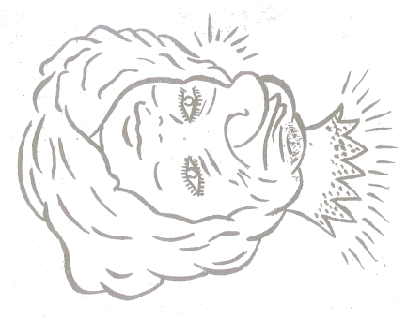

In a business seminar, three participants were given each a copy of the drawing in Figure 2 and asked to describe what they saw and also to explain their findings. The following were the findings:
- The first participant turned the drawing anti-clockwise and saw the impression of some beauty, as indicated in A below;
- The second participant retained the drawing as it was placed in front of him and described seeing a beauty’s as well as an elderly lady’s/granny’s face embracing each other in the drawing, as indicated in B below;
- The third participant turned the drawing clockwise and saw some granny’s face, as shown in C below



A B C

In his remarks, the Seminar presenter noted that the three participants had made the right observation, based on what they did (i.e turning the drawing anti-clockwise, retaining it as it was and turning it clockwise, respectively). He further noted that by virtue of the differences in the orientation of the drawing, the participants made different observations. He told the participants that the entrepreneurs, too, are prone to perceiving situations differently depending on the orientation of their minds. He gave the analogy of the beauty to be akin to the opportunity that attracts entrepreneurs to undertake the ventures that be and the granny to be akin to the challenges that stand on the way to exploiting the opportunity.

The seminar noted that the second participant had observed the bigger picture; opportunities lead to successful business ventures only if the associated challenges are identified and addressed. Entrepreneurs who only recognize the opportunity and do not seek to identify and address the challenges may end up galloping in the dark and having their enterprises not survive to enter the growth phase. On the other hand, getting overwhelmed with the challenges may discourage one from undertaking the venture. “To be able to see the bigger picture, entrepreneurial orientation is necessary”, the seminar concluded.

Entrepreneurial orientation is a firm-level construct (Covin & Slevin, 1991) that is closely linked to strategic management and the strategic decision making process (Birkinshaw, 1997; Burgelman, 1983; Kanter, 1982; Lumpkin & Dess, 1996; Naman & Slevin,1993).

Entrepreneurial orientation is also a process construct and concerns the “methods, practices, and decision making styles managers use” (Lumpkin & Dess, 1996). Based on the understanding, the essence of entrepreneurial orientation is how the entrepreneurs implement entrepreneurship in the course of realizing their career ambition.

Special Product Ideas
Business opportunities may exist in the following;
- Research and invention based products e.g. Drugs, medicine e.t.c.
- Skills /knowledge based products
Service Sector Ideas
These include household repair and maintenance, Service facilities, workshops and
establishments to cater for industrial and household needs.

Government Policies Priorities and Plans
These are allowed establishments by the government. The government can give incentives in terms of licensing, levies charged and taxes. These can give an indication of possible business ideas to take advantage of these policies.

SOURCES OF BUSINESS IDEAS

There are millions of entrepreneurs through out the world and their testimonies suggest that there are many potential sources of business ideas.

Hobbies/Interests:

A hobby is a favorite leisure time activity or occupation. Many people in pursuit of their hobbies or interests have founded businesses. If for example, you enjoy playing with computers, cooking, music, traveling, sport or performing, to name but a few, you may be able to develop it into a business. To illustrate this, if you enjoy traveling, performing and/or hospitality, you may consider going into tourism-which is one of the biggest industries in the world

Personal skills, experience and the Corridor Principle

Over half of the ideas for successful businesses come from experiences in the work place, e.g. a mechanic with experience in working for a large garage who eventually sets up his own car repair or used car business. Thus the background of potential entrepreneurs plays a crucial role in the decision to go into business as well as the type of venture to e created. Your skills and experience are probably your most important resource, not only in generating ideas but also in capitalizing on them.

Entrepreneurship is a market driven phenomenon (Hills, 1994) and market demand is one antecedent/prerequisite to opportunity recognition. Yet, one cannot rely solely on market demand to predict opportunity recognition, because in many cases the demand for a product is not explicit, particularly in the case of innovative new products which may be unknown to customers prior to introduction. However,
- having personal experience and knowledge of an industry may allow an entrepreneur to recognize market gaps and assess the market potential of a new venture (vesper 1996);
- Discussion with industry contacts and business associates may lead to opportunities.

According to Ronstadt’s (1988) corridor principle, once entrepreneurs found their firms, they begin a journey down a corridor, and as they proceed through the corridor, windows of opportunity open up around them. In this case the entrepreneurs would not see these opportunities if they had not entered the corridor.

- Franchises: a franchise is an arrangement whereby the manufacturer or sole distributor of a trade mark, product or service gives exclusive rights for local distribution to independent retailers in return for their payment of royalties and conformity to standardized operating procedures. Franchising may take several forms but the one of interest is the type that offers a name, image, method of doing business and operating procedures a good example is Uchumi Supermarket.

- Mass media: the mass media is a great source of information ideas and often opportunity. Newspapers, magazines, television and the internet are all examples of mass media. Take a careful look, for example, at the commercial advertisements in a newspaper or magazine and you may well find businesses for sale. Well, one way to become an entrepreneur is to respond to such an offer. Articles in printed press or on the internet or documentaries on television may report on changes on fashions or consumer needs. For example, you may read or hear that people are now increasingly interested in healthy eating or physical fitness. You may also find advertisements calling for the provision for certain services based on skills, for example accounting, catering, or security. Similarly you may discover a new concept for which investment is required namely franchising.

- Exhibitions: Attending exhibitions and trade fairs is another way of gathering business ideas. These are usually advertised on the radio or in newspapers. By visiting such events regularly, you will not only discover new products and services, but you will also meet sales representatives, manufacturers, wholesalers. Distributors and franchisers. These are often excellent sources of business ideas, information and help in getting started. Some of hem may also e looking for someone just like you.

- Surveys: The focal point of a new business idea should be the customer the needs and wants of the customer which provide the rationale for a product or service, can e ascertained through a survey. Such a survey might be conducted informally or formally by talking to people –usually using a questionnaire or through interviews-and through observation. You may start by talking to your friend and family to find out what they think is needed or wanted and is not available.

- Complaints: complaints and frustrations on the part of the customers have led to many new products or services. Whenever customers complain bitterly about a product or service or when you hear someone say “I wish there was “…or “if only there were a product or service that could….” you have the potential for a business idea. The idea could be to set up a rival firm offering a better product or service, or it might be a new product or service or it might be a new product or service that could be sold to the firm in question and/or to others.

- Brainstorming: brainstorming is a technique for creative problem solving as well as for generating ideas. The object is to come up with as many ideas as possible.
- Natural calamities: disasters like floods, tremors and drought may lead to the generation of business ideas.

Examples of such opportunity recognition and the ensuing business empires include:
- Bill Gates’ recognition of the Opportunity to come up with a versatile means of communication, which saw him found the Microsoft Corporation;
- Henry Ford’s recognition of the Opportunity to come up with an efficient means of transport, which saw him found the Ford Motor Corporation;
- Barry Potekin’s, recognition of the Opportunity to create wealth for himself by providing the people with delicious fast foods, which drove him to the found Gold Coast Dogs in Chicago;
- Honorable Thuo’s recognition of the Opportunity to provide organized transport to Nairobians which made him come up with Citi hoppa transport company; and
However, not all ideas are capable of being converted into practicable projects.
Differentiating an Opportunity from an Idea
- An opportunity must be:
- Attractive

- Durable

- Timely

- Add value to the end user

  - Opportunities are like diamonds – precious, but rare;
  - Ideas are like common stones – found everywhere.


Simone, in the article dated October 25th, 2007, observes that people tend to take two approaches to the arrival of an opportunistic knock at their door:
- they either morph into the welcome mat; or
- they morph into the do not disturb sign

Do Not Disturb Signs:
- Keep a locked door between them and the opportunity. They are wary and slow to respond.
- While they are secure in their distance from potential scammers and time-wasters, they also have to live with the regret of the great opportunity that moved on next door.

On the other hand, Welcome Mats are the first to greet an opportunity and often do so with enthusiasm.
- They can be easily convinced and are sometimes rewarded for getting in early on a good idea.
- On the down side they are also exposed to unwanted visitors bearing undesirable tidings, whose only real interest is to wipe their feet while they case the joint.
But there is a third group of people who reside elsewhere. They are the ones who know how to embrace an opportunity while minimizing their exposure to risk. They are the Opportunity Experts.

Major Ingredients of a Business Opportunity
Entrepreneurial opportunities which lead to business ventures have the following ingredients:
- Good market scope (gap between present or likely demand and supply)
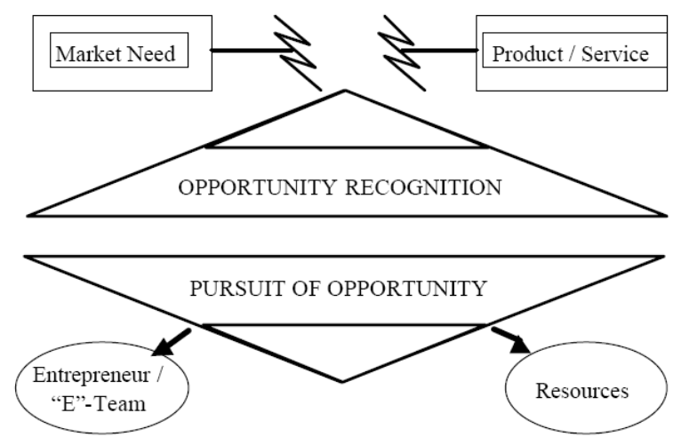
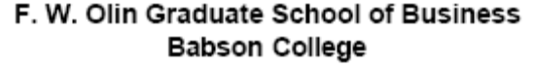

Opportunity recognition is also defined as recognizing the fit between a need in the marketplace and a product/service that meets that need. This calls for appropriate positioning of the entrepreneur’s antennae in order to peak the right signal for entrepreneurial opportunities

(ii) An attractive /acceptable return on investment.
Apart from the above, a business opportunity needs to be analysed for its viability in areas such as:
- technical skills
- production skills
- commercial skills
- managerial skills
The above are inter linked and the decision about one affects the others.
Out of the above criteria an entrepreneur will have to select only those ideas where his strengths are high.

Another aspect is that an idea may not be positive on all counts e.g. the market may be good but the technology very complicated, the returns may be very good but investments may be high.
PROCESS OF SELECTING A GOOD BUSINESS OPPORTUNITY
The process of selecting a project and stages through which an entrepreneur has to pass before reaching the final decision need to be carefully understood. Selection of the right business opportunity requires:
- Understanding ones own capabilities, strengths, limitations and preferences
- Exploring all possible opportunities available within existing conditions and environment
- Making a final decision after comparative analysis of opportunities available, which are consistent with the entrepreneur’s capabilities.
The PESTEL Framework

Entrepreneurial strategy formulation begins by assessing the resources controlled and controllable, it continues by analyzing the business environment. Figure 7 shows the business environment as a series of concentric circles. The innermost circle represents the firm and its resources. The next circle encompasses all the elements that are part of the firm’s industry but not part of the firm itself. The largest circle represents everything that is not part of the firm’s industry, the macro environment in which the firm operates. The segments within the macro environment:
Schematic representation of the New Venture’s Environment

Socio-Demographic

nEW vENTURE
Industry
Environment
PolitiCALcal
Economic
Technological
Socio-Demographic
Ecological

- Environmental scanning
Environmental Scanning is the ability to identify and interpret strong and weak signals from the trading environment. It is an essential skill:
- When looking for new enterprise opportunities
- To ensure the survival of established businesses
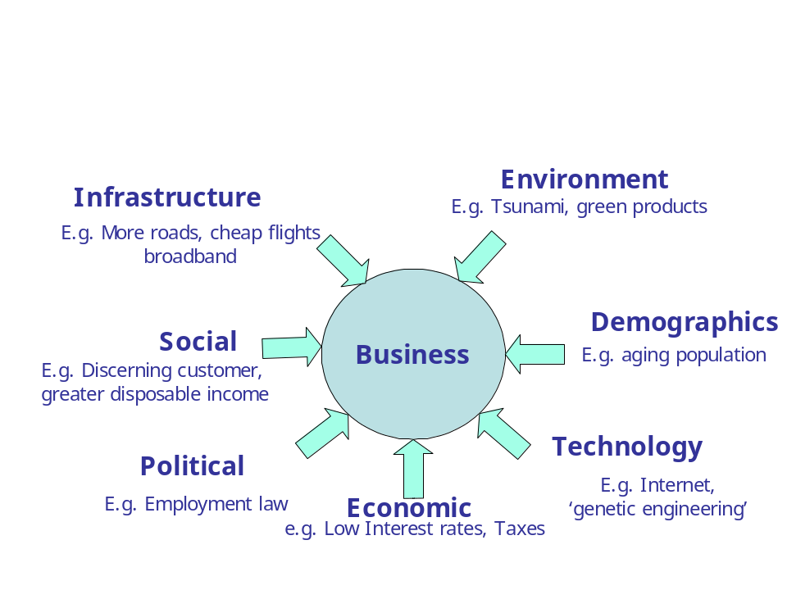This involves Political, Economic, Social, Technological, Environmental, Legal and regulatory forces (PESTEL) analysis

Environmental influences on a business

Scanning the trading environment can be used to categorise and measure the shifting forces that continually act on all traders. These forces are in a constant state of flux and can provide both new opportunities and new threats to survival. These are:
    - Political forces
    - Economic forces
    - Social forces
    - Technological forces
    - Environmental forces
    - Legal and regulatory forces

The PESTEL forces act and influence at a number of different geographical levels:
    - At world level (WTO, Kyoto Protocol, World Bank)
    - At trading bloc level (EU-ACP, COMESA, EAC)
    - At national level (Kenya government, Central Bank of Kenya, Kenya judiciary)
    - At regional level (regional development agencies)
    - At district level (local authority)
    - At sub-district level (ward level activists and communities)
Entrepreneurs and enterprises seek out opportunities through:
    - Looking for new experiences
    - Meeting poorly addressed needs e.g. Malaria treatment.
    - Making things better e.g. increased yield on Maize.
    - Matching emerging technologies to new potential users needs e.g. Diagnostics for breast cancer using DNA technology
    - Matching older technology or failed products to new markets e.g. Aspirin for blood thinning
Political Forces
Political Forces at play in an economy greatly influence business environment and this in turn would have profound impact on the nature of investment entrepreneurs would wish to consider. Among the salient features of the political forces include:
    - Employment legislation
    - Foreign trade regulation
    - Government political orientation and stability
    - Government policy to creating new knowledge
    - Lobbying mechanisms
    - Monopoly policy
    - Taxation policy
e.g. Increased support and government initiatives for bioscience exploitation

Economic forces
The ability to identify and interpret strong and weak signals from the trading environment is crucial to succeeding in a business. This is particularly essential:
  - When looking for new enterprise opportunities
  - To ensure the survival of established businesses
Entrepreneurs usually consider the following elements of economic forces when making a choice for their investment destination:
    - Business cycles
    - Capital availability
    - Credit control
    - Commodity and raw material cost & availability
    - Government economic policy
    - Energy costs and supply continuity
    - Exchange rates
    - Interest rates
    - Unemployment and workforce skill levels
Examples of influence of such economic forces include choosing to relocate a manufacturing venture to a country with lower energy costs and more incentives such as tax holidays.

Global issues
At the global level the main issues are trade barriers, tariffs, political risks, and bilateral and multilateral relationships. All of these issues are interrelated.
Trade barriers and tariffs. Trade barriers and tariffs hinder the free flow of resources across national boundaries. They are the result of economic interest groups within a country attempting to prevent transnational competition. Sometimes these tariffs and barriers can be justified as necessary leveling devices if the products in the country of origin are being subsidized.

Occasionally the rationale for tariffs and barriers is that they are needed to protect the home country’s emerging industries when they are most vulnerable. Later, however, when the home industry has grown and prospered, barriers and tariffs are almost never removed, for the protected industry now has gained enough political power to prevent the lowering of the barriers.

Social forces
Social cultural norms of a society can dictate what kind of businesses thrives and which ones do not. Entrepreneurs are therefore best advised to pay due consideration to:
    - Attitude and perception changes of populations
    - Censorship and press freedoms
    - Demographic trends (at world, trading block national and regional levels)
    - Education and skills levels
e.g. Negative public sentiment towards some biotech products

Technological forces
The level and scope of technology of an economy have an immense role to play in the opportunities available for entrepreneurs. Such technological aspects includes:
    - New developments & discoveries
    - Reducing product life cycles
    - Increasing rates of obsolescence
    - Rates of technological diffusion

Environmental forces
Today, the world is witnessing unprecedented wave of environmental awareness with consumer organizations setting the requirements for doing business ; businesses which are considered to be environmentally friendly have an edge over those that are not. Among the environmental issues that are increasingly gaining prominence includes:
    - Energy policies (domestic supply and transport)
    - Environmental protection policies
    - Governmental commitment to environmental protection
    - Waste disposal and recycling policies
    - Weather pattern change

Examples of business concerns include increasing cost of domestic power supply and global warming.

Legal and regulatory forces
Legal and regulatory environment of a country can greatly facilitate or impede business. The key aspects of concern to entrepreneurs include:
    - National employment legislation
    - National health and safety legislation
    - Intellectual property protection legislation
    - National monopoly policy
    - National planning policy
    - National product safety law
    - Speed of national legislative process & the vigour of enforcement forces.

Table 1: SWOT analysis example: the creation of own distributor company to access new end-user sectors not currently being developed
Strengths  - End-user sales control and direction.  - Right products, quality and reliability.  - Superior product performance vs competitors.  - Better product life and durability.  - Spare manufacturing capacity.  - Some staff have experience of end-user sector.  - Have customer lists.  - Direct delivery capability.  - Product innovations ongoing.  - Can serve from existing sites.  - Products have required accreditations.  - Processes and it should cope.  - Management is committed and confident. | Weaknesses  - Customer lists not tested.  - Some gaps in range for certain sectors.  - We would be a small player.  - No direct marketing experience.  - We cannot supply end-users abroad.  - Need more sales people.  - Limited budget.  - No pilot or trial done yet.  - Don't have a detailed plan yet.  - Delivery-staff need training.  - Customer service staff needs training.  - Processes and systems, etc  - Management cover insufficient.
Opportunities  - Could develop new products.  - Local competitors have poor products.  - Profit margins will be good.  - End-users respond to new ideas.  - Could extend to overseas.  - New specialist applications.  - Can surprise competitors.  - Support core business economies.  - Could seek better supplier deals. | Threats  - Legislation could impact.  - Environmental effects would favour larger competitors.  - Existing core business distribution risk.  - Market demand very seasonal.  - Retention of key staff critical.  - Could distract from core business.  - Possible negative publicity.  - Vulnerable to reactive attack by major competitors.

An entrepreneur, for example, will prefer a country where brand names are protected by patents than one where they are not. The issues identified from considering the PESTEL factor are then taking through the rigours of SWOT Analysis before making an investment decision.

SWOT Analysis
A scan of the internal and external environment is an important part of the strategic planning process. Environmental factors internal to the firm usually can be classified as strengths (S) or weaknesses (W), and those external to the firm can be classified as opportunities (O) or threats (T). Such an analysis of the strategic environment is referred to as a SWOT analysis.
The SWOT analysis provides information that is helpful in matching the firm's resources and capabilities to the competitive environment in which it operates. As such, it is instrumental in strategy formulation and selection. The following diagram shows how a SWOT analysis fits into an environmental scan:
SWOT analysis example
This SWOT analysis example is based on an imaginary situation. The scenario is based on a business-to-business manufacturing company, who historically rely on distributors to take their products to the end user market. The opportunity, and therefore the subject for the SWOT analysis, is for the manufacturer to create a new company of its own to distribute its products direct to certain end-user sectors, which are not being covered or developed by its normal distributors
Strengths
A firm's strengths are its resources and capabilities that can be used as a basis for developing a
competitive advantage. Examples of such strengths include:
- Patents
- Strong brand names
- Good reputation among customers
- Cost advantages from proprietary know-how
- Exclusive access to high grade natural resources
- Favorable access to distribution networks

Weaknesses
The absence of certain strengths may be viewed as a weakness. For example, each of the following may be considered weaknesses:
- Lack of patent protection
- A weak brand name
- Poor reputation among customers
- High cost structure
- Lack of access to the best natural resources
- Lack of access to key distribution channels
In some cases, a weakness may be the flip side of strength. Take the case in which a firm has a large amount of manufacturing capacity. While this capacity may be considered a strength that competitors do not share, it also may be a considered a weakness if the large investment in manufacturing capacity prevents the firm from reacting quickly to changes in the strategic environment.
Opportunities
The external environmental analysis may reveal certain new opportunities for profit and growth. Some examples of such opportunities include:
- An unfulfilled customer need
- Arrival of new technologies
- Loosening of regulations
- Removal of international trade barriers

Threats
Changes in the external environmental also may present threats to the firm. Some examples of such threats include:
- shifts in consumer tastes away from the firm's products
- Emergence of substitute products
- New regulations
- Increased trade barriers
The SWOT Matrix
A firm should not necessarily pursue the more lucrative opportunities. Rather, it may have a better chance at developing a competitive advantage by identifying a fit between the firm's strengths and upcoming opportunities. In some cases, the firm can overcome a weakness in order to prepare itself to pursue a compelling opportunity.
To develop strategies that take into account the SWOT profile, a matrix of these factors can be constructed. The SWOT matrix (also known as a TOWS Matrix) is shown below:
SWOT Matrix
 | Strengths | Weaknesses
Opportunities | S-O strategies | W-O strategies
Threats | S-T strategies | W-T strategies
Source: Bradford, Robert W., Duncan, Peter J., Tarcy, Brian, Simplified Strategic Planning:
- S-O strategies pursue opportunities that are a good fit to the company's strengths.
- W-O strategies overcome weaknesses to pursue opportunities.
- S-T strategies identify ways that the firm can use its strengths to reduce its vulnerability to external threats.
- W-T strategies establish a defensive plan to prevent the firm's weaknesses from making it highly susceptible to external threats.
Characteristics of a Good Business Opportunity
(i) Demand
This means that there is a good market scope for the product or service i.e there is a gap existing between the present supply and current or likely demand e.g. available products / services are not enough to reach every one who requires them, starting such a business means there will be people who will want to pay for your products/services.

(ii) Attractive return on investment
Entrepreneurs want to generate more money than what they put into a business. One is expected to know the returns on an investment. If the returns are higher, then the project can be pursued, if not then the owner would need to change it.

(iii) Availability of raw materials.
Raw materials are very important for production. One would require finding out whether there are any raw materials required and if present, then the project may be viable e.g. plenty of fruit grown may imply that fruit processing is possible.

(iv.). Skills requirements
Some businesses require certain skills to start and run e.g. a Medical/Veterinary Clinic or Accountancy Firm. If the specialised skills required are available then one can venture into that business.

Entrepreneurial ventures, no matter how exciting or fast growing they may seem, must acknowledge the rules of enterprise and business wisdom that apply to the industry and competitive environment in which the ventures are launched. Knowledge in a specific domain is required.

In opportunity recognition, as with all fields of business, there is no substitute for experience. Entrepreneurs who know a business domain will have a better chance for correctly recognizing opportunities than those who have no experience in the domain. High levels of domain knowledge enhance opportunity recognition.

